|  |  |
| --- | --- |
| 1 | b |
| 2 | c |
| 3 | d |
| 4 | b |
| 5 | d |
| 6 | a |
| 7 | b |
| 8 | c |
| 9 | c |
| 10 | a |
| 11 | b |
| 12 | d |
| 13 | b |
| 14 | c |
| 15 | d |
| 16 | Free |
| 17 | b |
| 18 | a |
| 19 | c |
| 20 | c |
| 21 | a |
| 22 | c |
| 23 | d |
| 24 | d |
| 25 | a |
| 26 | c |
| 27 | c |
| 28 | a |
| 29 | b |
| 30 | c |

31.

3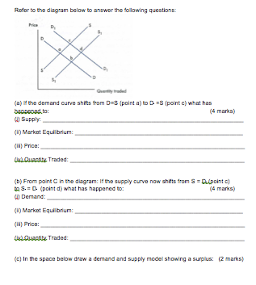2.

33.

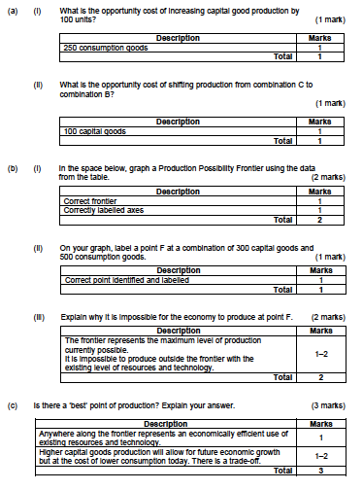

34.

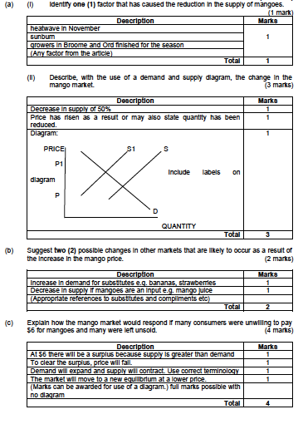

35.

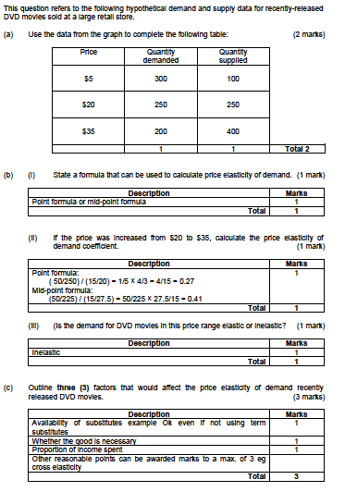

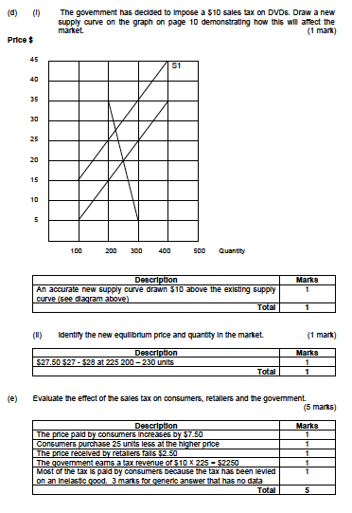

3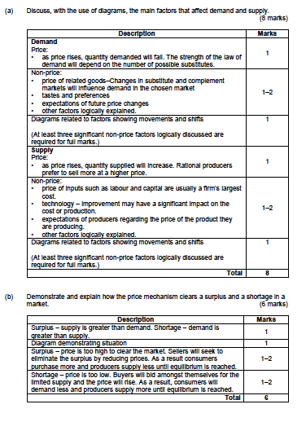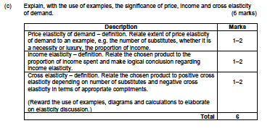5.

36.

a.) Describe the meaning of price elasticity of supply.

**(3 marks)**

| **Description** | **Mark** |
| --- | --- |
| Definition of Elasticity | 1 |
| Definition of Supply | 1 |
| Use of either graph or formula in explanation | 1 |

b.) Using examples distinguish between a good that is supply elastic and one that is supply inelastic.

| **Description** | **Mark** |
| --- | --- |
| Correct example of a Supply Elastic good | 1-2 |
| Correct example of a Supply Elastic good | 1-2 |

c.) Give an example of a good that is perfectly supply inelastic.

| **Description** | **Mark** |
| --- | --- |
| Correct example | 1 |
| Use of graph, coefficient or formula | 1 |

d.) explain three (3) factors that determine price elasticity of supply.

| **Description** | **Mark** |
| --- | --- |
| Factors:  Time  Expectations  Resources  Stocks/Inventories | 1 mark for each factor  1 mark for correct explanation & example |

**(6 marks)**